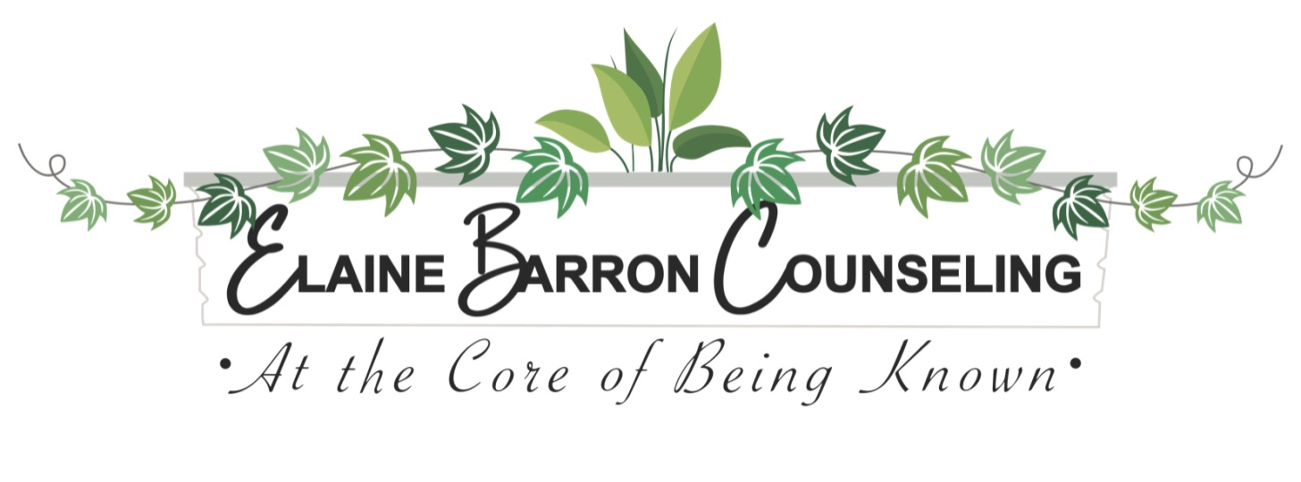
12700 Century Dr. Suite E elainebarronlcsw@gmail.com
Alpharetta, GA 30009 678-807-9868

Informed Consent for Psychotherapy

General Information: The therapeutic relationship is unique in that it is a highly personal and at the same time, a contractual agreement. Given this, it is important for us to reach a clear understanding about how our relationship will work, and what each of us can expect. This consent will provide a clear framework for our work together. Feel free to discuss any of this with me. Please read and indicate that you have reviewed this information and agree to it by filling in the checkbox at the end of this document.

The Therapeutic Process: You have taken a very positive step by deciding to seek therapy. The outcome of your treatment depends largely on your willingness to engage in this process, which may, at times, result in considerable discomfort. Remembering unpleasant events and becoming aware of feelings attached to those events can bring on strong feelings of anger, depression, anxiety, etc. There are no miracle cures. I cannot promise that your behavior or circumstance will change. I can promise to support you and do my very best to understand you and repeating patterns, as well as to help you clarify what it is that you want for yourself.

Confidentiality: The session content and all relevant materials to the client’s treatment will be held confidential unless the client requests in writing to have all or portions of such content released to a specifically named person/persons. Limitations of such client held privilege of confidentiality exist and are itemized below:

1. If a client threatens or attempts to commit suicide or otherwise conducts him/her self in a manner in which there is a substantial risk of incurring serious bodily harm.

2. If a client threatens grave bodily harm or death to another person.

3. If the therapist has a reasonable suspicion that a client or other named victim is the perpetrator, observer of, or actual victim of physical, emotional or sexual abuse of children under the age of 18 years.

4. Suspicions as stated above in the case of an elderly person who may be subjected to these abuses.

5. Suspected neglect of the parties named in items #3 and # 4.

6. If a court of law issues a legitimate subpoena for information stated on the subpoena.

7. If a client is in therapy or being treated by order of a court of law, or if information is obtained for the purpose of rendering an expert’s report to an attorney.

Occasionally I may need to consult with other professionals in their areas of expertise in order to provide the best treatment for you. Information about you may be shared in this context without using your name.

If we see each other accidentally outside of the therapy office, I will not acknowledge you first. Your right to privacy and confidentiality is of the utmost importance to me, and I do not wish to jeopardize your privacy. However, if you acknowledge me first, I will be more than happy to speak briefly with you, but feel it appropriate not to engage in any lengthy discussions in public or outside of the therapy office.

_______________________________________________ __________________________________________

Client Signature Date

Elaine Barron License CSW06886, #CSW06886, #RN205833 Elaine Barron Counseling 12700 Century Dr. Suite E Alpharetta, GA 30009 (678) 807-9868

